Business Requirements Document

<< Project Number >>

<< Project and Name >>

**VERSION: N.N**

DATE <<YYYY-MM-DD >>

# Version and Approvals

**UTORS**

|  |  |
| --- | --- |
| **Version History** | |
| **Version #** | **Date** | | **Revised By** | **Reason for change** |
|  |  | |  |  |
|  |  | |  |  |
|  |  | |  |  |
|  |  | |  |  |

Content changes between the current version and the previous version are identified using the Blackline convention (i.e., additions and ~~deletions~~).

This document has been approved as the official Business Requirements Document for <project name>, and accurately reflects the current understanding of business requirements. Following approval of this document, requirement changes will be governed by the project’s change management process, including impact analysis, appropriate reviews and approvals.

|  |  |
| --- | --- |
| **Document Approvals** | |
| **Approver Name** | **Project Role** | | **Signature/Electronic Approval** | **Date** |
|  |  | |  |  |
|  |  | |  |  |
|  |  | |  |  |
|  |  | |  |  |

**Table of Contents**

Version and Approvals 2

Project Details 2

Overview 2

Document Resources 2

Glossary of Terms 3

Project Overview 3

4.1 Project Overview and Background 3

4.2 Project Dependencies 3

4.3 Stakeholders 3

Key Assumptions and Constraints 4

5.1 Key Assumptions and Constraints 4

(OPTIONAL) Use Cases 4

Use Case Diagram 4

Use Case Narrative 5

Business Requirements 8

General / Base 8

Security 8

Reporting 9

Usability 9

Audit 9

Appendixes 10

Appendix A – Business Process Flows 10

Appendix B – Business Rules Catalog 13

Appendix C- Models 13

Use Case Narrative Instructions 13

Project Details

|  |  |
| --- | --- |
| **Project Name** | Enter Project Name |
| **Project Type** | ***(e.g. New Initiative or Phase II)*** |
| **Project Start Date** |  |
| **Project End Date** |  |
| **Project Sponsor** |  |
| **Primary Driver** | ***(e.g. Mandatory or Efficiency)*** |
| **Secondary Driver** |  |
| **Division** |  |
| **Project Manager** |  |

Overview

This document defines the high level requirements [insert project name]. It will be used as the basis for the following activities:

* Creating solution designs
* Developing test plans, test scripts, and test cases
* Determining project completion
* Assessing project success

Document Resources

*<Complete or insert Stakeholder Map>*

| **Name** | **Business Unit** | **Role** |
| --- | --- | --- |
| <Identify all stakeholders and resources involved in gathering requirements> |  |  |
|  |  |  |
|  |  |  |
|  |  |  |
|  |  |  |

Glossary of Terms

| **Term/Acronym** | **Definition** |
| --- | --- |
| <Identify any terms and acronyms used within this document> |  |
|  |  |
|  |  |
|  |  |
|  |  |
|  |  |
|  |  |
|  |  |
|  |  |
|  |  |
|  |  |
|  |  |

Project Overview

## 4.1 Project Overview and Background

<This is a brief description of what the project is about. It includes the current situation, the problem and the objectives. This section serves as the vision statement for the requirements. Each requirement should bring the project closer to the vision.>

## 4.2 Project Dependencies

<List any related known projects that relate in whole or in part, or has a dependency on this project.>

## 4.3 Stakeholders

The following comprises the internal and external stakeholders whose requirements are represented by this document:

|  | **Stakeholders** |
| --- | --- |
| 1. |  |
| 2. |  |
| 3. |  |

Key Assumptions and Constraints

## 5.1 Key Assumptions and Constraints

|  |  |
| --- | --- |
| **#** | **Assumptions** |
|  | List any assumptions the requirements are based on |
|  |  |
|  |  |
|  |  |
|  |  |
|  |  |
| **#** | **Constraints** |
|  | List any constraints the requirements are based on |
|  |  |
|  |  |
|  |  |
|  |  |
|  |  |

(OPTIONAL) Use Cases

<The primary purpose of the Use Case is to capture the required system behavior from the perspective of the end-user in achieving one or more desired goals. A Use Case contains a description of the flow of events describing the interaction between actors and the system. The use case may also be represented visually in UML in order to show relationships with other the use cases and actors>.

## Use Case Diagram

## 

## Use Case Narrative

<Each Use Case should be documented using this template. Refer to the Appendix for Use Case Narrative instructions>

|  |  |  |  |
| --- | --- | --- | --- |
| Use Case ID: |  | | |
| Use Case Name: |  | | |
| Created By: |  | Last Updated By: |  |
| Date Created: |  | Date Last Updated: |  |

|  |  |
| --- | --- |
| Actors: |  |
| Description: |  |
| Preconditions: |  |
| Postconditions: |  |
| Normal Course: |  |
| Alternative Courses: |  |
| Exceptions: |  |
| Includes: |  |
| Priority: |  |
| Frequency of Use: |  |
| Business Rules |  |
| Special Requirements: |  |
| Assumptions: |  |
| Notes and Issues: |  |
| Use Case Graphic | |

***Example of a completed use case:***

|  |  |  |  |
| --- | --- | --- | --- |
| Use Case ID: | 1 | | |
| Use Case Name: | View Interactive Campus Map | | |
| Created By: | Dan Sward | Last Updated By: |  |
| Date Created: | 4/19/09 | Date Last Updated: |  |

|  |  |
| --- | --- |
| Actors: | User |
| Description: | This use case describes the main way this interactive campus map will be used – as a web browser accessed application. The user accesses the appropriate URL and interacts with the functionality made available. |
| Preconditions: | Web browser opened, and interactive campus map URL accessed. |
| Postconditions: | User navigates from interactive campus map web site. |
| Normal Course: | 1. Open browser 2. Navigate to campus map URL 3. Interact with the campus map using available functionality |
| Alternative Courses: | None |
| Exceptions: | None |
| Includes: |  |
| Priority: | High |
| Frequency of Use: | Once per visit. |
| Business Rules | TBD… |
| Special Requirements: | * 24/7 access * Response times comparable to common web mapping solutions (e.g. Google Maps) * U of M accessibility requirements * U of M eCommunications requirements |
| Assumptions: |  |
| Notes and Issues: |  |
| Use Case Graphic | UseCase1 |

Business Requirements

The following sections document the various business requirements of this project.

The requirements in this document are prioritized as follows:

|  |  |  |
| --- | --- | --- |
| Value | Rating | Description |
| 1 | Critical | This requirement is critical to the success of the project. The project will not be possible without this requirement. |
| 2 | High | This requirement is high priority, but the project can be implemented at a bare minimum without this requirement. |
| 3 | Medium | This requirement is somewhat important, as it provides some value but the project can proceed without it. |
| 4 | Low | This is a low priority requirement, or a “nice to have” feature, if time and cost allow it. |
| 5 | Future | This requirement is out of scope for this project, and has been included here for a possible future release. |

*<Remove Use Case column if use case section of BRD was removed>*

## General / Base

|  |  |  |  |  |
| --- | --- | --- | --- | --- |
| *REQ#* | PRIORITY | DESCRIPTION | RATIONALE | USE CASE |
| *<ID>* | *<value>* | *<The system shall allow up to 100 concurrent users>* | *<data suggests high of 45 concurrent users, need room to expand>* | *<#>* |
|  |  |  |  |  |
|  |  |  |  |  |
|  |  |  |  |  |
|  |  |  |  |  |
|  |  |  |  |  |

## Security

|  |  |  |  |  |
| --- | --- | --- | --- | --- |
| *REQ#* | PRIORITY | DESCRIPTION | RATIONALE | USE CASE |
|  |  |  |  |  |
|  |  |  |  |  |
|  |  |  |  |  |
|  |  |  |  |  |
|  |  |  |  |  |
|  |  |  |  |  |

## Reporting

|  |  |  |  |  |
| --- | --- | --- | --- | --- |
| *REQ#* | PRIORITY | DESCRIPTION | RATIONALE | USE CASE |
|  |  |  |  |  |
|  |  |  |  |  |
|  |  |  |  |  |
|  |  |  |  |  |
|  |  |  |  |  |
|  |  |  |  |  |

## Usability

|  |  |  |  |  |
| --- | --- | --- | --- | --- |
| *REQ#* | PRIORITY | DESCRIPTION | RATIONALE | USE CASE |
|  |  |  |  |  |
|  |  |  |  |  |
|  |  |  |  |  |
|  |  |  |  |  |
|  |  |  |  |  |
|  |  |  |  |  |

## Audit

|  |  |  |  |  |
| --- | --- | --- | --- | --- |
| *REQ#* | PRIORITY | DESCRIPTION | RATIONALE | USE CASE |
|  |  |  |  |  |
|  |  |  |  |  |
|  |  |  |  |  |
|  |  |  |  |  |
|  |  |  |  |  |
|  |  |  |  |  |

Appendixes

## Appendix A – Business Process Flows

<Describe the current existing process workflow using flow diagrams (i.e. Visio Flowcharts) and/or a detailed narrative.>

### *As Is Diagrams*

<Insert As Is Diagrams here (if applicable)>

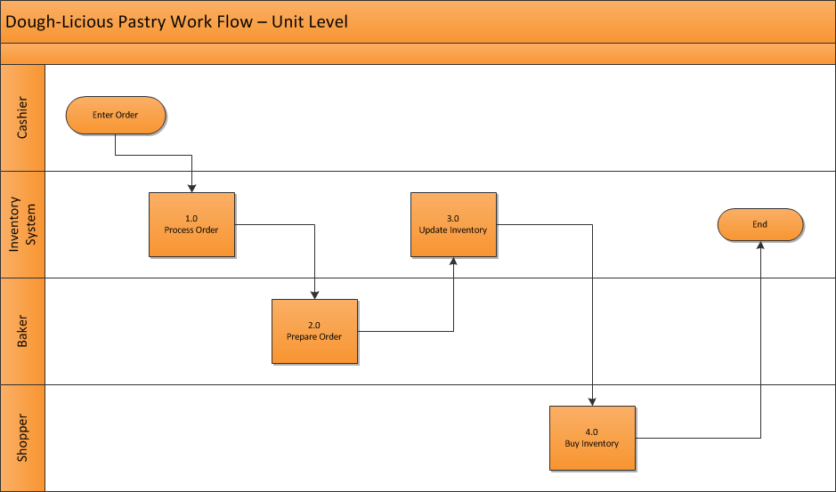*To Be Diagrams*

<Insert To Be Diagrams here (if applicable)>



## Appendix B – Business Rules Catalog

<Instructions: Use the following template for each business rule. >

|  |  |
| --- | --- |
| Business Rule Name: | <The name should give you a good idea about the topic of the business rule.> |
| Identifier | <Defines unique identifier.> *EXAMPLE: BR1* |
| Description | <Defines the rule in detail.> *EXAMPLE: “All employee labor is tracked, reported and billed in 15 minute increments.”* |
| Example | <(Optional) An example of the rule> |
| Source | <Source of the rule. E.g. stakeholder> |
| Related Rules | <List of related rules, to support traceability> |

## Appendix C- Models

<Insert models here>

## Use Case Narrative Instructions

<Instructions for completing the Use Case Narrative are included here. Remove these instructions from the completed Business Requirements Document>.

| **Use Case Field Name** | **Definition** |
| --- | --- |
| Use Case ID | Give each use case a unique numeric identifier, in hierarchical form: X.Y. Related use cases can be grouped in the hierarchy. Functional requirements can be traced back to a labeled Use Case. |
| Use Case Name | State a concise, results-oriented name for the use case. These reflect the tasks the user needs to be able to accomplish using the system. Include an action verb and a noun. Some examples:   * View part number information. * Manually mark hypertext source and establish link to target. * Place an order for a CD with the updated software version |
| Created By | Include the name of the person who initially documented this Use Case. |
| Date Created | Enter the date on which the use case was initially documented |
| Date Last Updated | Enter the date on which the use case was most recently updated |
| Last Updated By | Include the name of the person who performed the most recent update to the use case description. |
| Actor | Enter the person or other entity external to the software system being specified who interacts with the system and performs use cases to accomplish tasks. Different actors often correspond to different user classes, or roles, identified from the customer community that will use the product. Name the actor(s) that will be performing this Use Case. |
| Description | Provide a brief description of the reason for and outcome of this use case, or a high-level description of the sequence of actions and the outcome of executing the Use Case. |
| Preconditions | List any activities that must take place, or any conditions that must be true, before the Use Case can be started. Number each precondition. Examples:   * User’s identity has been authenticated. * User’s computer has sufficient free memory available to launch task |
| Post conditions | Describe the state of the system at the conclusion of the use case execution. Number each post condition. Examples:   * Document contains only valid SGML tags. * Price of item in database has been updated with new value |
| Normal Course | Provide a detailed description of the user actions and system responses that will take place during execution of the use case under normal, expected conditions. This dialog sequence will ultimately lead to accomplishing the goal stated in the use case name and description. This description may be written as an answer to the hypothetical question, “How do I <accomplish the task stated in the use case name>?” This is best done as a numbered list of actions performed by the actor, alternating with responses provided by the system. |
| Alternative Courses | Document other, legitimate usage scenarios that can take place within this use case separately in this section. State the alternative course, and describe any differences in the sequence of steps that take place. Number each alternative course using the Use Case ID as a prefix, followed by “AC” to indicate “Alternative Course”. Example: X.Y.AC.1 |
| Exceptions | Describe any anticipated error conditions that could occur during execution of the use case, and define how the system is to respond to those conditions. Also, describe how the system is to respond if the use case execution fails for some unanticipated reason. Number each exception using the Use Case ID as a prefix, followed by “EX” to indicate “Exception”. Example: X.Y.EX.1 |
| Includes | List any other use cases that are included (“called”) by this use case. Common functionality that appears in multiple use cases can be split out into a separate use case that is included by the ones that need that common functionality. |
| Priority | Indicate the relative priority of implementing the functionality required to allow this use case to be executed. The priority scheme used must be the same as that used in the software requirements specification. |
| Frequency of Use | Estimate the number of times this Use Case will be performed by the actors per some appropriate unit of time. |
| Business Rules | List any business rules that influence this Use Case. |
| Special Requirements | Identify any additional requirements, such as nonfunctional requirements, for the use case that may need to be addressed during design or implementation. These may include performance requirements or other quality attributes. |
| Assumptions | List any assumptions that were made in the analysis that led to accepting this use case into the product description and writing the use case description. |
| Notes and Issues | List any additional comments about this use case or any remaining open issues or TBDs (To Be Determined) that must be resolved. Identify who will resolve each issue, the due date, and what the resolution ultimately is. |